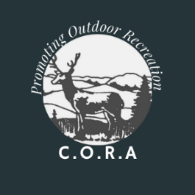
Tuesday, January 6th, 2026 Meeting Minutes
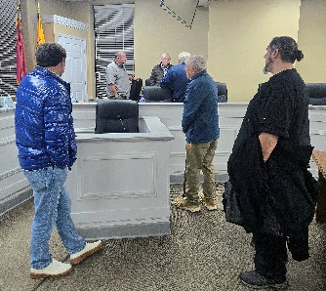
The meeting was called to order at 7:08pm. Reverend Ronald Lambert led the invocation. Secretary Tidwell called roll with 9 members present and 5 absent. December 2025’s meeting minutes were read and accepted. In the absence of Chairman Bill Stanley, Vice-president Ronald Lambert led the meeting.
Treasurer Coy Crutchfield gave his report with a balance of $10,098.54 currently on the books.
For the publicity report, E. L. Morton will see about getting the monthly CORA meetings listed in the event sections of the LaFollette Press.
In the newsletter and distribution report, President Lewis asked Tidwell and Overton to check on the advertisers and the collection of the ad fees.
In the Hunters for the Hungry report, Overton gave the figures for the last three years of venison donations: 2023 at 4,828 lbs., 2024 at 4,511 lbs., and 2025 at 4,028 lbs. He has picked up two churches as distribution sites. A discussion on freezers, refrigerated trailers, and possible pick-ups of donated venison by Fred Walker followed.
The spread of CWD, eastward in Tennessee, was discussed. It seems as if the disease is creeping ever closer to the North Cumberland Wildlife Management Area.
Fred Walker discussed forward momentum on his proposal for a special flintlock rifle deer season. He also discussed the OHV fee revision and the TFWC’s possible vote on the matter in March.
President Lewis discussed the alternative funding revenue streams being considered for TWRA. It is reported that some in the state legislature might want to introduce a bill for “land liquidation” as a one-time funding mechanism for TWRA. In theory, money would be made selling the land, and money would be saved by not having to manage the liquidated parcels.
The sale of public lands would be something that CORA would be officially opposed to. Public acreage is highly valued in our state. Once a public tract is potentially sold and developed, it could never be replaced.
The last item discussed is the case involving the City of Sweetwater legally battling with a group of duck hunters. The issue involves hunting rights within an area defined as within the city limits of a municipality. The case is still in litigation.
It was noted that founding CORA board member Glen Massengill passed away on Sunday, January 4th, 2026 at the age of 84. Visitation is scheduled for 5-7pm Wednesday, January 7that Caryville First Baptist Church.
The meeting dismissed at 7:50pm.
